🕒 Runtime Controller



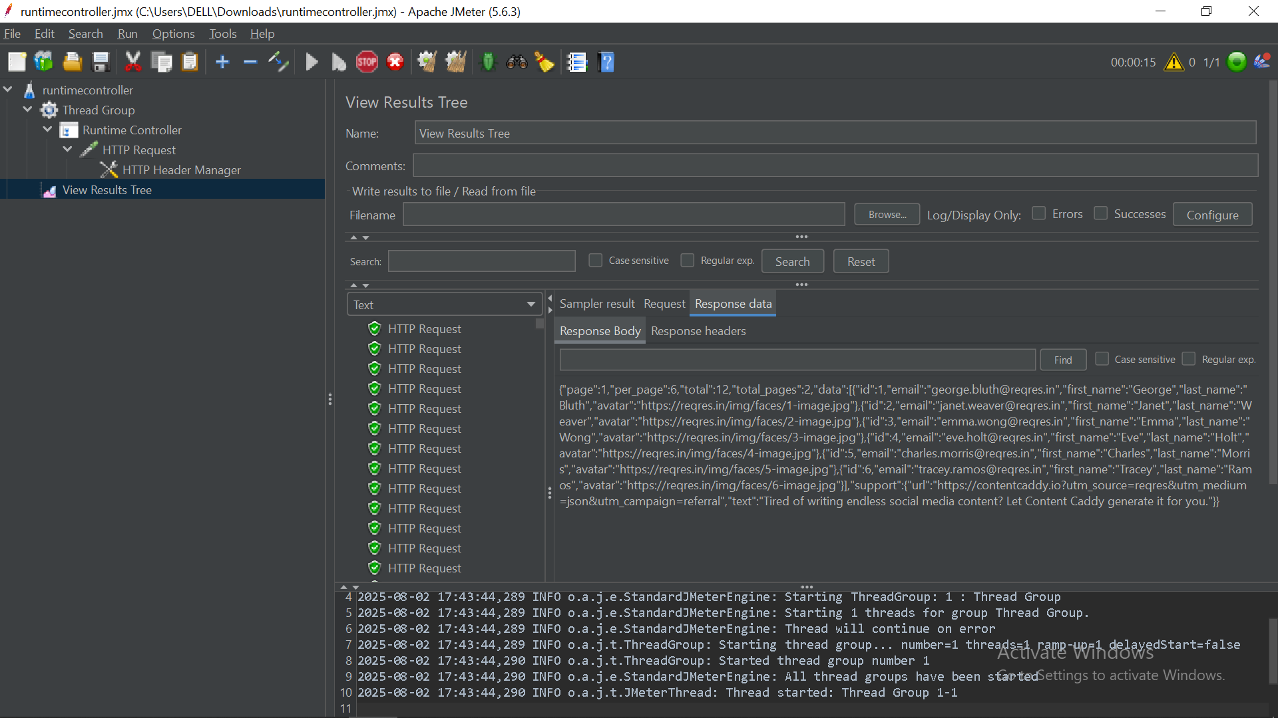

The **Runtime Controller** is a **Logic Controller** in JMeter that controls the **duration** for which its child elements (samplers, logic controllers, etc.) are executed. It **does not rely on the loop count** of the Thread Group, making it ideal for **time-based test scenarios**.

**✅ Key Characteristics**

**1. Time-Based Execution**

* Executes its child elements **for a specified duration** (in seconds).
* Once the duration is exceeded, the controller stops executing its child elements—**regardless of loop counts**.

**2. Overrides Loop Count**

* If the **Thread Group’s loop count** is high but the Runtime Controller is configured with a **shorter duration**, execution will stop once the time is up.
* If the **Runtime** is longer than the loop count, it keeps repeating the child elements within the time limit.

**3. Real-World Simulation**

* Useful when simulating behavior like:  
  *“User browses a website for 60 seconds”*.
* Within that window, JMeter will **loop through the actions repeatedly** (e.g., view product, add to cart) until the time runs out.

**4. Thread Group Interaction**

* The total execution time is affected by:
  + **Ramp-up period** of the Thread Group
  + **Runtime** of the controller
* Example:
  + 5 threads, 5-second ramp-up
  + Runtime Controller set to 5 seconds
  + ⏱ Test may last **up to 10 seconds** (because the last thread starts at 5s and runs for 5s)

**5. Best Used with Infinite Loops**

* Often combined with:
  + **Thread Group** with loop count = Forever (-1)
  + **Loop Controller** set to Forever
* Ensures that child samplers execute **as many times as possible within the specified duration**

**📌 When to Use**

* Simulating continuous activity for a **fixed duration**
* Running a test for **load generation for a specific time window**
* Ensuring that time constraints are met even if the number of iterations isn't fixed

**🔧 Configuration Steps**

1. Add **Runtime Controller** to your Test Plan.
2. Place your samplers/controllers as its child elements.
3. Set the **duration in seconds**.
4. Optionally, set your Thread Group or Loop Controller to loop **forever** to utilize full runtime.

**🧠 Example Scenario**

* **Goal**: Simulate user actions for 60 seconds
* **Setup**:
  + Thread Group: 10 users, loop = forever
  + Runtime Controller: duration = 60
  + Inside: Samplers for login, browse, add to cart
* **Result**: Each user performs the actions continuously for 60 seconds